Children with Allergies Policy



“Learning hand in hand with our friend Jesus.”

PREPARED BY: Frank Crawford
RATIFIED BY: Governing Body
DATE: November 2023
REVIEW DATE: November 2024

- Introduction

An allergy is a reaction of the body’s immune system to substances that are usually harmless. The reaction can cause minor symptoms such as itching, sneezing or rashes but sometimes causes a much more serious reaction called anaphylaxis.

Anaphylaxis is a serious, life-threatening allergic reaction. It is at the extreme end of the allergic spectrum. The whole body is affected often within minutes of exposure to the allergen, but sometimes it can be hours later. Causes can include foods, insect stings, and drugs.

Most healthcare professionals consider an allergic reaction to be anaphylaxis when it involves difficulty breathing or affects the heart rhythm or blood pressure. Anaphylaxis symptoms are often referred to as the ABC symptoms (Airway, Breathing, Circulation).

It is possible to be allergic to anything which contains a protein, however most people will react to a fairly small group of potent allergens.

Common UK Allergens include (but are not limited to): -
Peanuts, Tree Nuts, Sesame, Milk, Egg, Fish, Latex, Insect venom, Pollen and Animal Dander.

This policy sets out how St Mary St Michael School will support pupils with allergies, to ensure
they are safe and are not disadvantaged in any way whilst taking part in school life.

- Role and responsibilities

Parent Responsibilities
  - On entry to the school, it is the parent’s responsibility to inform reception staff of any allergies. This information should include all previous serious allergic reactions, history of anaphylaxis and details of all prescribed medication.
  - Parents are to supply a copy of their child’s Allergy Action Plan (BSACI plans preferred) to school. If they do not currently have an Allergy Action Plan this should be developed as soon as possible in collaboration with a healthcare professional
e.g. School nurse/GP/allergy specialist.
  - Parents are responsible for ensuring any required medication is supplied, in date and replaced as necessary.
  - Parents are requested to keep the school up to date with any changes in allergy management. The Allergy Action Plan will be kept updated accordingly.

Staff Responsibilities
  - All staff will complete anaphylaxis training. Training is provided for all staff on a yearly basis and on an ad-hoc basis for any new members of staff.
  - Staff must be aware of the pupils in their care (regular or cover classes) who have known allergies as an allergic reaction could occur at any time and not just at mealtimes. Any food-related activities must be supervised with due caution.
  - Staff leading school trips will ensure they carry all relevant emergency supplies. Trip leaders will check that all pupils with medical conditions, including allergies, carry their medication. Pupils unable to produce their required medication will not be able to attend the excursion.
  - School Nurse/SENCO/First Aider (delete or substitute as appropriate) will ensure that the up-to-date Allergy Action Plan is kept with the pupil’s medication.
  - Children that have significant allergies will need to wear their yellow allergies badges to indicate to the school catering staff what types of food that they are allergic too.
  - It is the parent’s responsibility to ensure all medication in in date however the SENCO/Lead First Aider will check medication kept at school on a termly basis and send a reminder to parents if medication is approaching expiry.
  - The SENCO/Lead First Aider keeps a register of pupils who have been prescribed an adrenaline auto-injector (AAI) and a record of use of any AAI(s) and emergency treatment given.

Pupil Responsibilities
  - Pupils are encouraged to have a good awareness of their symptoms and to let an adult know as soon as they suspect they are having an allergic reaction.
  - Pupils who are trained and confident to administer their own AAIs will be encouraged to take responsibility for carrying them on their person at all times.

- Allergy Action Plans

Allergy action plans are designed to function as individual healthcare plans for children with food allergies, providing medical and parental consent for schools to administer medicines in the event of an allergic reaction, including consent to administer a spare adrenaline auto- injector.
St Mary St Michael School uses the British Society of Allergy and Clinical Immunology (BSACI) Allergy Action Plans to ensure continuity. This is a national plan that has been agreed by the BSACI, Anaphylaxis UK and Allergy UK.

It is the parent/carer’s responsibility to complete the allergy action plan with help from a healthcare professional (e.g. GP/School Nurse/Allergy Specialist) and provide this to the school.

- Emergency Treatment and Management of Anaphylaxis

What to look for:
Symptoms usually come on quickly, within minutes of exposure to the allergen.

Mild to moderate allergic reaction symptoms may include:
- a red raised rash (known as hives or urticaria) anywhere on the body
- a tingling or itchy feeling in the mouth
- swelling of lips, face or eyes
- stomach pain or vomiting.

More serious symptoms are often referred to as the ABC symptoms and can include:

- AIRWAY - swelling in the throat, tongue or upper airways (tightening of the throat, hoarse voice, difficulty swallowing).
- BREATHING - sudden onset wheezing, breathing difficulty, noisy breathing.
- CIRCULATION - dizziness, feeling faint, sudden sleepiness, tiredness, confusion, pale clammy skin, loss of consciousness.

The term for this more serious reaction is anaphylaxis. In extreme cases there could be a dramatic fall in blood pressure. The person may become weak and floppy and may have a sense of something terrible happening. This may lead to collapse and unconsciousness and, on rare occasions, can be fatal.

If the pupil has been exposed to something they are known to be allergic to, then it is more likely to be an anaphylactic reaction.

Anaphylaxis can develop very rapidly, so a treatment is needed that works
rapidly. Adrenaline is the mainstay of treatment, and it starts to work within seconds.

What does adrenaline do?
- It opens up the airways
- It stops swelling
- It raises the blood pressure

As soon as anaphylaxis is suspected, adrenaline must be administered without delay. Action:

- Keep the child where they are, call for help and do not leave them unattended.
- LIE CHILD FLAT WITH LEGS RAISED – they can be propped up if struggling to breathe but this should be for as short a time as possible.
- USE ADRENALINE AUTO-INJECTOR WITHOUT DELAY and note the time given. AAIs should be given into the muscle in the outer thigh. Specific instructions vary by brand – always follow the instructions on the device.
- CALL 999 and state ANAPHYLAXIS (ana-fil-axis).
- If no improvement after 5 minutes, administer second AAI.
- If no signs of life commence CPR.
- Call parent/carer as soon as possible.
- Whilst you are waiting for the ambulance, keep the child where they are. Do not stand them up, or sit them in a chair, even if they are feeling better. This could lower their blood pressure drastically, causing their heart to stop.
- All pupils must go to hospital for observation after anaphylaxis even if they appear to have recovered as a reaction can reoccur after treatment.

- Supply, storage and care of medication

Depending on their level of understanding and competence, pupils will be encouraged to take responsibility for and to carry their own two AAIs on them at all times (in a suitable bag/container).

For younger children or those not ready to take responsibility for their own medication, there should be an anaphylaxis kit which is kept safely, not locked away and accessible to all staff.

Medication is stored in the classroom in a suitable container and clearly labelled with the pupil’s name. The pupil’s medication storage container should contain:
- One AAIs i.e. EpiPen® or Jext® or Emerade®
- An up-to-date allergy action plan
- Antihistamine as tablets or syrup (if included on allergy action plan)
- Spoon if required
- Asthma inhaler (if included on allergy action plan).

It is the responsibility of the child’s parents to ensure that the anaphylaxis kit is up-to-date and clearly labelled, however the SENCO/ Lead First Aider will check medication kept at school on a termly basis and send a reminder to parents if medication is approaching expiry.

Parents can subscribe to expiry alerts for the relevant AAIs their child is prescribed, to make sure they can get replacement devices in good time.

Storage
AAIs are stored at room temperature, protected from direct sunlight and temperature extremes in both the classrooms and medical room.

Disposal
AAIs are single use only and must be disposed of as sharps. Used AAIs can be given to ambulance paramedics on arrival or can be disposed by giving them to the parents when they have expired.

‘Spare’ adrenaline auto-injectors in school

St Mary St Michael School has purchased spare AAIs for emergency use in children who are risk of anaphylaxis, if their own devices are not available or not working (e.g. because they are out of date).

These are stored in a white locked box in the medical room clearly labelled ‘Emergency
Anaphylaxis Adrenaline Pen’, kept safely, not locked away and accessible and known to all staff.

The SENCO/Lead First Aider is responsible for checking the spare medication is in date on a monthly basis and to replace as needed.

Written parental permission for use of the spare AAIs is included in the pupil’s allergy action plan.

If anaphylaxis is suspected in an undiagnosed individual call the emergency services and state you suspect ANAPHYLAXIS. Follow advice from them as to whether administration of the spare AAI is appropriate.

- Staff Training

The named staff members responsible for co-ordinating staff anaphylaxis training and the upkeep of the school’s anaphylaxis policy are:-

Clair Brown

Samantha Fenton

Gill Green

All Teaching Assistants will complete online Allergy Wise anaphylaxis training at the start of every new academic year. Training is also available on an ad-hoc basis for any new members of staff.

Training includes:
- Knowing the common allergens and triggers of allergy
- Spotting the signs and symptoms of an allergic reaction and anaphylaxis. Early recognition of symptoms is key, including knowing when to call for emergency services
- Administering emergency treatment (including AAIs) in the event of anaphylaxis – knowing how and when to administer the medication/device
- Measures to reduce the risk of a child having an allergic reaction e.g. allergen avoidance, knowing who is responsible for what
- Managing allergy action plans and ensuring these are up to date

- A practical session using trainer devices (these can be obtained from the manufacturers’ websites: www.epipen.co.uk and www.jext.co.uk and www.emerade-bausch.co.uk)

- Inclusion and safeguarding

St Mary St Michael School is committed to ensuring that all children with medical conditions, including allergies, in terms of both physical and mental health, are properly supported in school so that they can play a full and active role in school life, remain healthy and achieve their academic potential.

- Catering

All food businesses (including school caterers) must follow the Food Information Regulations 2014 which states that allergen information relating to the ‘Top 14’ allergens must be available for all food products.

The school menu is available for parents to view in weekly on the website. This is sent out to parents at the start of a new menu cycle.

The School Office/ SENCo will inform the Catering Manager of pupils with food allergies. These children will then wear a yellow badge informing the catering staff as to what they are allergic too.

The school adheres to the following Department of Health guidance recommendations:

- Bottles, other drinks and lunch boxes provided by parents for pupils with food allergies should be clearly labelled with the name of the child for whom they are intended.
- The pupil should be taught to also check with catering staff, before selecting their lunch choice.
- Where food is provided by the school, staff should be educated about how to read labels for food allergens and instructed about measures to prevent cross contamination during the handling, preparation and serving of food. Examples include: preparing food for children with food allergies first; careful cleaning (using

warm soapy water) of food preparation areas and utensils. For further information, parents/carers are encouraged to liaise with the Catering Manager.
- Food should not be given to primary school age food-allergic children without parental engagement and permission (e.g. birthday parties, food treats).
- Use of food in crafts, cooking classes, science experiments and special events (e.g. fetes, assemblies, cultural events) needs to be considered and may need to be restricted/risk assessed depending on the allergies of particular children and their age.

- School trips

Staff leading school trips will ensure they carry all relevant emergency supplies. Trip leaders will check that all pupils with medical conditions, including allergies, carry their medication. Pupils unable to produce their required medication will not be able to attend the excursion.

All the activities on the school trip will be risk assessed to see if they pose a threat to allergic pupils and alternative activities planned to ensure inclusion.

Overnight school trips should be possible with careful planning and a meeting for parents with the lead member of staff planning the trip should be arranged. Staff at the venue for an overnight school trip should be briefed early on that an allergic child is attending and will need appropriate food (if provided by the venue).
- Sporting Excursions

Allergic children should have every opportunity to attend sports trips to other schools. The school will ensure that the P.E. teacher/s are fully aware of the situation. The school being visited will be notified that a member of the team has an allergy when arranging the fixture. A member of staff trained in administering adrenaline will accompany the team. If another school feels that they are not equipped to cater for any food-allergic child, the school will arrange for the child to take alternative/their own food.

Most parents are keen that their children should be included in the full life of the school where possible, and the school will need their co-operation with any special arrangements required.

- Allergy awareness and nut bans

St Mary and St Michael Catholic Primary School supports the approach advocated by Anaphylaxis UK towards nut bans/nut free schools. They would not necessarily support a blanket ban on any particular allergen in any establishment, including in schools. This is because nuts are only one of many allergens that could affect pupils, and no school could guarantee a truly allergen free environment for a child living with food allergy. They advocate instead for schools to adopt a culture of allergy awareness and education.

A 'whole school awareness of allergies' is a much better approach, as it ensures teachers, pupils and all other staff are aware of what allergies are, the importance of avoiding the pupils’ allergens, the signs & symptoms, how to deal with allergic reactions and to ensure policies and procedures are in place to minimise risk.

- Risk Assessment

St Mary and St Michael Catholic Primary School, with support from the school nurse, will conduct a detailed individual risk assessment for all new joining pupils with allergies and any pupils newly diagnosed, to help identify any gaps in our systems and processes for keeping allergic children safe.

Appendices 1

Useful Links

Anaphylaxis UK - https://www.anaphylaxis.org.uk/

- Safer Schools Programme - https://www.anaphylaxis.org.uk/education/safer- schools-programme/

- AllergyWise for Schools online training - https://www.allergywise.org.uk/p/allergywise-for-schools1

Allergy UK - https://www.allergyuk.org

- Whole school allergy and awareness management - https://www.allergyuk.org/schools/whole-school-allergy-awareness- andmanagement

BSACI Allergy Action Plans - https://www.bsaci.org/professional- resources/resources/paediatric-allergy-action-plans/

Spare Pens in Schools - http://www.sparepensinschools.uk

Department for Education Supporting pupils at school with medical conditions - https://assets.publishing.service.gov.uk/government/uploads/system/uploads/attachment_ data/file/803956/supporting-pupils-at-school-with-medical-conditions.pdf

Department of Health Guidance on the use of adrenaline auto-injectors in schools - https://assets.publishing.service.gov.uk/government/uploads/system/uploads/attachment_ data/file/645476/Adrenaline_auto_injectors_in_schools.pdf

Food allergy quality standards (The National Institute for Health and Care Excellence, March 2016) https://www.nice.org.uk/guidance/qs118

Anaphylaxis: assessment and referral after emergency treatment (The National Institute for Health and Care Excellence, 2020) https://www.nice.org.uk/guidance/cg134?unlid=22904150420167115834

Appendices 1

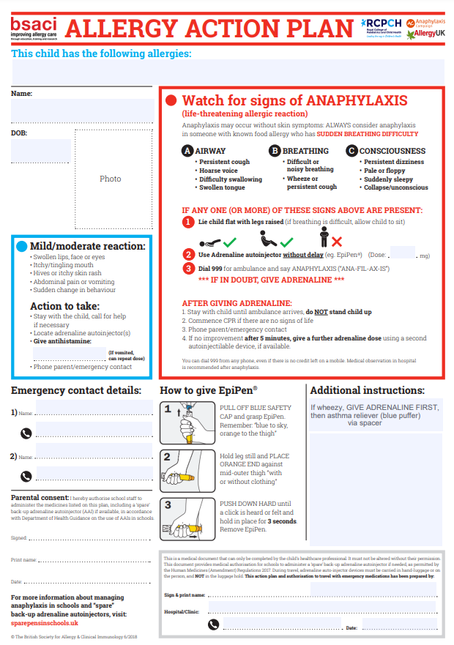

Appendix:2

Individual Health Care Plan (IHCP)

" |  | Name: Date of Birth: NHS Number:  School:  Class/form:  Date of Plan:
I have the following medical condition(s):

*Please follow my action plan(s) attached•
My medication and medical equipment is kept in: The classroom
Parent/guardian/carer 1 |  |  | Parent/guardian/caret 2
Name:  Relationship: |  |  | Name:  Relationship:
Contact Number: |  |  | Contact Number:

- It is the responsibility of the parents to ensure that any child who needs any
medication/medical devices in school, is in date and has a prescription label.
- All medication should be available to the child/pupil at au times during the school day
including when they are offsite (e.g.PE, school trips) and accompanied by the IHCP.

Appendix:3

