St Mary and St Michael
Catholic Primary School

First Aid Policy



“Learning together hand in hand with our friend Jesus.”

First Aid Policy

Policy Statement

The Governors and Headteacher of St Mary & St Michael Catholic Primary School accept their responsibility under the Health and Safety (First Aid) regulations 1981 and acknowledge the importance of providing First Aid for employees, children and visitors within the school.

The Governors are committed to the authority’s procedure for reporting accidents and recognise their statutory duty to comply with the Reporting of injuries, diseases and dangerous occurrences regulations 1995.

The provision of First Aid within the school will be in accordance with the Authority’s guidance on First Aid in school.

Statement of First Aid organisation
The school’s arrangements for carrying out the policy include nine key principles:

- Places a duty on the Governing body to approve, implement and review the policy.
- Place individual duties on all employees.
- To report, record and where appropriate investigate all accidents.
- Records all occasions when first aid is administered to employees, pupils and visitors.
- Provide equipment and materials to carry out first aid treatment.
- Make arrangements to provide training to employees, maintain a record of that training and review annually.
- Establish a procedure for managing accidents in school which require First Aid treatment.
- Provide information to employees on the arrangements for First Aid.
- Undertake a risk assessment of the first aid requirements of the school.

Arrangements for First Aid

Materials, equipment and facilities
The school will provide materials, equipment and facilities as set out in DfE ‘Guidance on First Aid for schools’.

The location of First Aid Kits in school are;

- Main Hall
- Music Room
- Early Years Foundation Stage Unit
- Staffroom
- Playground

The medical room is designated first aid room for major and minor incidents that happen throughout the school day. At breaktime and lunchtime medical minor medical incidents are dealt with at the first aid station in the playground.

Asthma pumps and epi-pens for named individuals should be kept within the classroom in named wallets with the child’s name and individual care plan. The school also keeps three spare blue asthma inhalers and four epipen kits (2 x 15mg and 2 x 30mg.)

Cuts
The nearest adult deals with small cuts. All open cuts should be covered after they have been treated.

A fully trained first aider must treat severe cuts. Minor cuts should be recorded in the accident log. Severe cuts should be recorded in the accident log and parents informed by telephone call. A major incident form needs to be filled out by the person dealing with the injury and given to the parents. Major injuries need to be reported to the appointed person.

ANYONE TREATING AN OPEN CUT SHOULD USE RUBBER GLOVES.

Head Injuries
Any bump to the head, no matter how minor is treated as serious. All bumped heads should be treated with an ice pack. All bumped head accidents should be recorded in the accident log.

Regardless of how minor the head injury appears to be ALL children with a bumped head should be given a head injury form to be taken home. It may be that the child becomes unwell after school and the information will be helpful to parents if they need to see a doctor.

If there is a visible mark, the member of staff administering first aid will speak to a member of SLT, who will advise if a parent needs to be phoned immediately. Each head injury will be recorded on the head injury form and put in the head injury folder. A photocopy of this form advising of the injury is sent home with the child. This will be done by the school office. All parents will be sent a text if their child has a head injury.

If an accident occurs during break or lunchtime the first aider must ensure that the class teacher is aware of the injury. The adults in the child’s classroom should keep a close eye on the child. (Appendix 3 & 4)

Allergic reaction
Staff are trained in recognising the signs of serious allergic reactions and named staff trained in the administration of epi-pens. In case of a less serious allergic reaction a first aider should examine the child and follow care plan instructions. Please also see the section on ‘Arrangements for Medicine at School’.

Record Keeping

First Aid and Medicine Files
These files are kept in the medical room. The contents of these files are collected at the end of the academic year by the appointed person and kept together for a period of 3 years as required by law. The school follows the HSE guidance on reportable accidents/incidents for children and visitors.

Employees/Staff
The school has a responsibility to provide first aid to all staff. In case of an accident/incident staff should seek First Aid from any of the qualified First Aiders. All first Aid treatment to staff should be recorded in the staff accident log, located in the medical room. In case an accident/incident results in the individual being taken to hospital, where they receive treatment and are absent from work for 3 days or more, the appointed person needs to be notified. The appointed person, Business Manager and the Headteacher will review the accident/incident and decide if it needs to be reported to the HSE.

Notifying Parents
The school uses two different forms for parent notification. These are:
- Head Injury Form
- Major Incident form

These forms can be found in the medical room.

Arrangements for Medicine in School

Administering medicine in school
At the beginning of each academic year, any medical conditions are shared with staff and a list of these children and their conditions is kept in the Teacher’s files/Inclusion folder/First-Aid Medicine Record files and on the School Management System.

Children with medical conditions have to have a care plan provided by the school nurse, signed by parents/guardians. Medications kept in the school for children with medical needs are stored in the medical room. Each child’s medication is in a clearly labelled container with their care plan. For further information on pupils with medical conditions in school please see the ‘Supporting Children with Medical Needs’ policy.

All medicines in school are administered following the agreement of a care plan.

Asthma
Children with asthma do not always require a care plan. In order for children’s asthma pumps to be kept in school an ‘Asthma Pump Card’ form must be filled out. It is the parent/carers responsibility to provide up to date asthma pumps for their children. The appointed person keeps a record of the expiry date on the pumps and informs the parents should the pumps expire or run out. Parents can choose to allow their child to carry their asthma pumps and it should be carried by the person who it has been prescribes to and clearly labelled with the child’s name. Asthma sufferers should not share inhalers. In addition, parents are asked to also supply an inhaler that is kept in class, in case the child loses or damages the inhaler they carry.

Only the blue (reliever) asthma pumps should be kept in school. For more information, please see our asthma and allergies policy.

Short Term Prescriptions
Medications such as the short term use of antibiotics or painkillers can be administered only if the parent/carer fills out the ‘Parental consent for administering medicine’ form on the day the request is made. The form can be obtained from the school office. There are also hard copies in the medical room. Parents need to give the completed form to the school office together with the medication. The office is to notify the person responsible for medicine (Mrs Green), who will inform the relevant member of staff. A completed copy of the ‘Parental consent form for administering medicine’ form must be kept in the Administering Medicine folder. However, staff should encourage parents to administer medicine at home. Medication may be administered in school if it is required to be taken four times a day. Only medication prescribed by a GP, hospital or pharmacy and clearly labelled with the child’s name, address and required dosage can be administered in school. Non-prescription medication or creams and lotions should not be administered in school. (Appendix 1)

Medications that need to be kept in the fridge are stored in the medical room. Children must always be aware of where their medicine is kept.

If a child refuses to take a medicine, staff should not force them to do so. Instead they should note this in the records and inform parents/carers or follow agreed procedures or the Care Plan.

Record-keeping – Medicine
Staff should record any instances when medicine is administered. This includes if children use their asthma pumps. The records need to include date and time of medicine administered, its name and the dose given, signed by the person responsible for administering the medicine. Older children may take their own medicine under the supervision of an adult; this needs to be recorded and the adult still needs to sign the record sheet. Record sheets are in the Administering Medicines folder. (Appendix 2)

Calling the Emergency Services
In case of a major accident, it is the decision of the fully trained first aider if the emergency services are to be called. Staff are expected to support and assist the trained first aider in their decision. The Headteacher or Deputy Headteacher should be informed if such a decision has been made even if the accident happened on a school trip on or a school journey.

If the casualty is a child, their parents/carers should be contacted immediately and given all the information required. If the casualty is an adult, their next of kin should be called immediately. All contact numbers for children and staff are available from the school office.

Headlice
Staff do not touch children and examine them for headlice. If we suspect a child or children have headlice we will have to inform the parents/carers. A standard letter should be sent home with all the children in that class where the suspected headlice incident is.

Chicken Pox and other diseases, rashes
If a child is suspected of having chicken pox, measles etc; we will look at the child’s arms or legs. Chest and back will only be looked at if we are further concerned. We should call a first aider and two adults should be present. The child should always be asked if it was ok to look.

For the inspection of other rashes the same procedure should be followed. If we suspect the rash to be contagious (such as scabies, impetigo, conjunctivitis, etc) we need to inform parents and request that children are treated before they are returned to school. In most cases once treatment has begun it is safe for children to return to school. If a number of children are suspected to have the same disease/rash in one class/school a letter should be sent home to all parents in that class/classes, to inform them as to allow them to spot problems early and began treatment, thus avoid the further spread of the disease/rash.

It is the Headteachers duty to decide if there is an outbreak of infectious disease and whether there is a need to report it to the local HPU (Health Protection Unit).

Training
Names of staff trained in First Aid are displayed in the main hall, music room, EYFS Unit and the staffroom.

Whole staff training for First Aid (4 hour course) will be undertaken every three years and all teaching and support staff will be invited to attend when necessary.

The next whole staff First Aid Training should be organised for September 2024.

Off Site Activities
At least one first aid kit will be taken on all off-site activities, along with individual pupil’s medication such as inhalers, epi-pens etc.

A person who has been trained in first aid will accompany all off-site visits.

Information on First Aid Arrangements
The Headteacher will inform all employees at the school of the following:
- The arrangements for reporting and recording accidents;
- The arrangements for First Aid;
- Those employees with qualifications in First Aid;
- The location of First Aid kits.

In addition the Headteacher will ensure that signs are displayed throughout the school providing the following information:
- Names of employees with first aid qualifications.

- Location of First Aid boxes.

All members of staff will be made aware of the school’s first aid policy.

Accident Reporting
The Governors will implement the LA’s procedures for reporting:
- All accidents to employees
- All incidents of violence and aggression
- The Governing Body is aware of its statutory duty under RIDDOR in respect of reporting the following to the Health and Safety executive as it applies to employees
- An accident that involves an employee being incapacitated from work for more than three consecutive days
- An accident which requires admittance to hospital for in excess of 24 hours
- Death of an employee
- Major injury such as fracture, amputation, dislocation of shoulder, hip, knee or spine.

For non-employees and pupils an accident will only be reported under RIDDOR:
- Where it is related to work being carried out by an employee or contractor and the accident results in death or major injury, or;
- It is an accident at school which requires immediate emergency treatment at hospital.

For eachinstancewhere the Headteacher considers an accident to a visitor or pupil is reportable under RIDDOR the advice of the authority will be sought.

Where a pupil has an accident it will be reported to the LA.
All accidents to non-employees (e.g.visitors) which result in injury will be reported to the authority.

Transport to hospital or home
- The Headteacher will determine what is a reasonable and sensible action to take in each case;
- Where the injury is an emergency an ambulance will be called following which the parent will be called;
- Where hospital treatment is required but it is not an emergency, then the Headteacher will contact the parents/carers to take over responsibility for the child;
- If the parents/carers cannot be contacted, then the Headteacher may decide to transport the pupil to hospital;
- Where the Headteacher makes arrangements for transporting the child then the following points will be observed:
- Only staff cars insured to cover such transportation will be used.
- No individual member of staff should be alone with a pupil in a vehicle.
- The second member of staff will be present to provide supervision for the injured pupil.

Updated: November 2023
Review date: November 2024

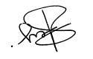
Signed: Headteacher

Appendix 1
St Mary and St Michael Catholic Primary School

Parent Consent Form to Store and Administer Medicine

Childs Name:
Date of Birth:

Class:

Illness/Condition:

Medicine:

Start Date: |  | Finish Date: |  | Expiry Date:

Dosage: |  | Frequency/Time:

Storage:

Self –administration? (with first aider present) | Yes No
Emergency Contact:

I give consent for the school to store and administer my child’s medicine according to the above instructions.
I will notify the school of any changes to my child’s medication or treatment plan.

Signed:

Date:

Relationship to child:

Signed on behalf of the school:

Medicine returned (date and to who):
Medicine returned (by who):

Appendix 2
St Mary and St Michael Catholic Primary School

Record of Administration

Name of pupil: |  | Class:

Date | Dosage | Time | Self Administered | Signed  Child or Staff 1 | Countersigned  Staff 1 or Staff 2
 |  |  | Yes/No
 |  |  | Yes/No
 |  |  | Yes/No
 |  |  | Yes/No
 |  |  | Yes/No
 |  |  | Yes/No
 |  |  | Yes/No
 |  |  | Yes/No
 |  |  | Yes/No
 |  |  | Yes/No
 |  |  | Yes/No
 |  |  | Yes/No
 |  |  | Yes/No
 |  |  | Yes/No
 |  |  | Yes/No
 |  |  | Yes/No
 |  |  | Yes/No
 |  |  | Yes/No
 |  |  | Yes/No

Appendix 3

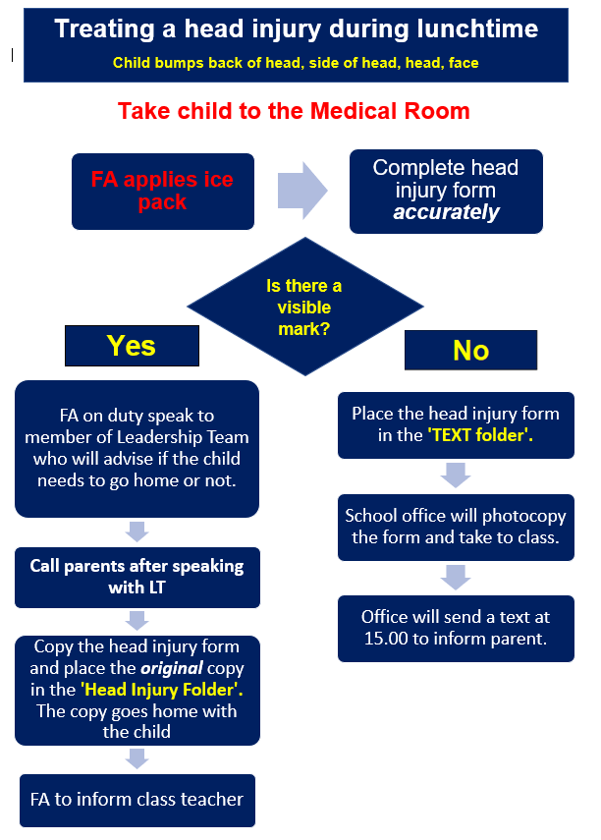

Appendix 4
