Your data – What you need to know
The St Mary & St Michael Catholic Primary School will collect some information, or ‘data’, about you while you’re a pupil. They have to look after your data very carefully or they will break the law. This factsheet explains how they do it.

What data do we collect about you?

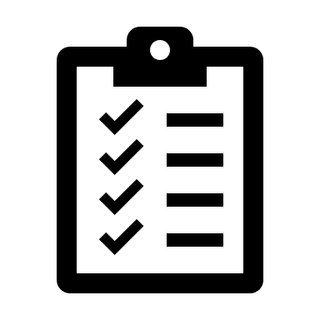
- We will collect your name and address and those of your parents or carers.
- We will collect data about you and your family’s culture and traditions, any languages you speak.
- When we take the register or roll call, we record whether or not you are at school. If you’re not very well your parents might give us a note from your doctor. If you have can’t eat certain food or need to take special medicine, we will need to know to make sure you are OK in school.
- We make a note of any help you might need in the classroom, if you need free school meals or if your and your family need any support from the school or the local council.
- We keep a list of all the marks you get at school in different subjects, so the teachers and your parents or carers can work out how well you are doing and if you need any help.
- As a school we have to keep track of any bad behaviour so everyone at the school can be happy and stay safe.
- We might take some photos or footage of our school events and put them on our website

Where do we get it from?
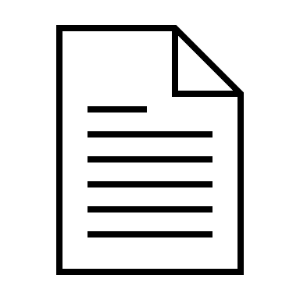
- Mostly we get your data from your parents or carers when you enrol at the school and during your time as a pupil
- Sometimes the school might get given your data from the school you just came from or from the local council, if they’ve been helping you.

Why do we need your data?

- To help you learn in the classroom and at home
- To keep track on how each pupil is doing in their school work
- To help look after you and keep you safe
- To make sure the school knows it is doing well, both by itself and compared against how other schools are doing
- When we take a photo of a class activity, we do it to show people on our website what the school does

St Mary & St Michael Catholic Primary Schools does this because:
- The law says schools have to collect this data and use it for these things
- Schools are special places and education is very important
- If we use your photo we will ask you and your parents or carers first
- There are special laws about your health and safety and your family’s culture and traditions that the School needs your data for

Who do we share the data with?
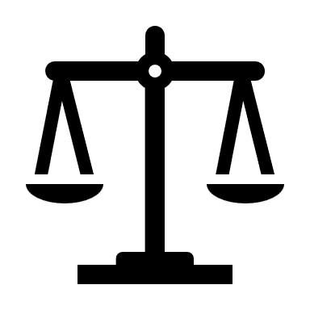
- Your parents and carers, where they need to know
- The school you go on to next, so they know about you when you arrive
- The local council, if you or your parents or carers need any help
- The education department at the government, who like to look at statistics for the whole country so they can plan how to help schools
- The police, if there is a serious investigation or incident
- Any company the school uses to help them store data or carry out tasks

Where does my data go?
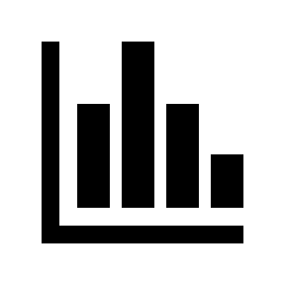
- Your data can be stored on computers at the school building or in special rooms in different places, that the school controls
- If the school has to send your data outside of the country, it still needs to obey the law in the UK to look after your data

Can I see my data?

As a school pupil you have special powers, or ‘rights’, under the law to do the following:
- See what data the school collects about you
- Make something correct where the school has made a mistake
- Ask the school to delete some data or take it down from the website
- Stop using your data in a certain way
The school can do some of these things but the law sometimes makes us say no. We will explain this to you and your parents or carers when you ask

How long do we keep your data for?

Even when you leave our school, St Mary & St Michael Catholic Primary Schools are required by law to keep your data for longer, sometimes until you are an adult. The school has a special document called a retention schedule which tells us how long to keep information for.

How do I find out more?

You can ask your schoolteacher if you have any questions.
The school has a person they work with called a ‘Data Protection Officer’, who makes sure that the school is following the law, and you can contact them on IG@Connetix.co.uk
There is also a special organisation called the Information Commissioner’s Office, who makes sure that every school or business follows the law. They have a lot of information on their website https://ico.org.uk/your-data-matters/ and you can complain to them if you are not happy about what the school has done with your data https://ico.org.uk/global/contact-us/

For parents - This factsheet is based on the DFE Model Privacy Notice to cover the school’s GDPR obligations to be transparent about how we use personal data.
https://www.gov.uk/government/publications/data-protection-and-privacy-privacy-notices
You can find out more about our data protection policies from the school website or contact us with any questions.

