
The Governing Body of

St Mary & St Michael Catholic Primary School
Admissions Policy for the 2026/27 academic year
St Mary & St Michael Catholic Primary School was founded by the Catholic Church to provide education for children of Catholic families. The school is conducted by its Governing Body as part of the Catholic Church in accordance with its trust deed and instrument of government. It seeks at all times to be a witness to Jesus Christ.
As a Catholic school, we aim to provide a Catholic education for all our pupils. At a Catholic school, Catholic doctrine and practice permeate every aspect of the school’s activity. It is essential that the Catholic character of the school’s education is fully supported by all families in the school. All applicants are therefore expected to give their full, unreserved and positive support for the aims and ethos of the school.
The Published Admissions Number (PAN) for the reception year group is 60. The Governing Body has sole responsibility for admissions to this school and intends to admit 60 pupils to the reception year group in the school year which begins in September 2026.
Whenever there are more applications than places available, priority will always be given to Catholic applicants in accordance with the oversubscription criteria, listed below
Within this policy ‘applicant’ refers to you, the parent applying for a place, and ‘candidate’ refers to the child for whom the application is made.

Oversubscription Criteria
Where there are more applications for places than the number of places available, places will be offered according to the following order of priority:
- Catholic ‘looked after’ children and Catholic children who have been adopted or made subject to child arrangements orders or special guardianship orders, immediately following having been looked after.
- Baptised Catholic children with a Certificate of Catholic Practice who are resident in the parish of St Mary & St Michael.
- Baptised Catholic children with a Certificate of Catholic Practice who live within other parishes in the Tower Hamlets Deanery, with priority given to those who live nearest to the school. The parishes in the Tower Hamlets Deanery are:

Wapping Poplar
Tower Hill Bethnal Green
Underwood Road Bow
Limehouse Bromley-by-Bow
Mile End Millwall

If you are unsure which parish you live in, please go to the following website where you can view maps of all the parishes within the Tower Hamlets Deanery:
http://catholicdirectory.org/Catholic_Information.asp?ID=37521

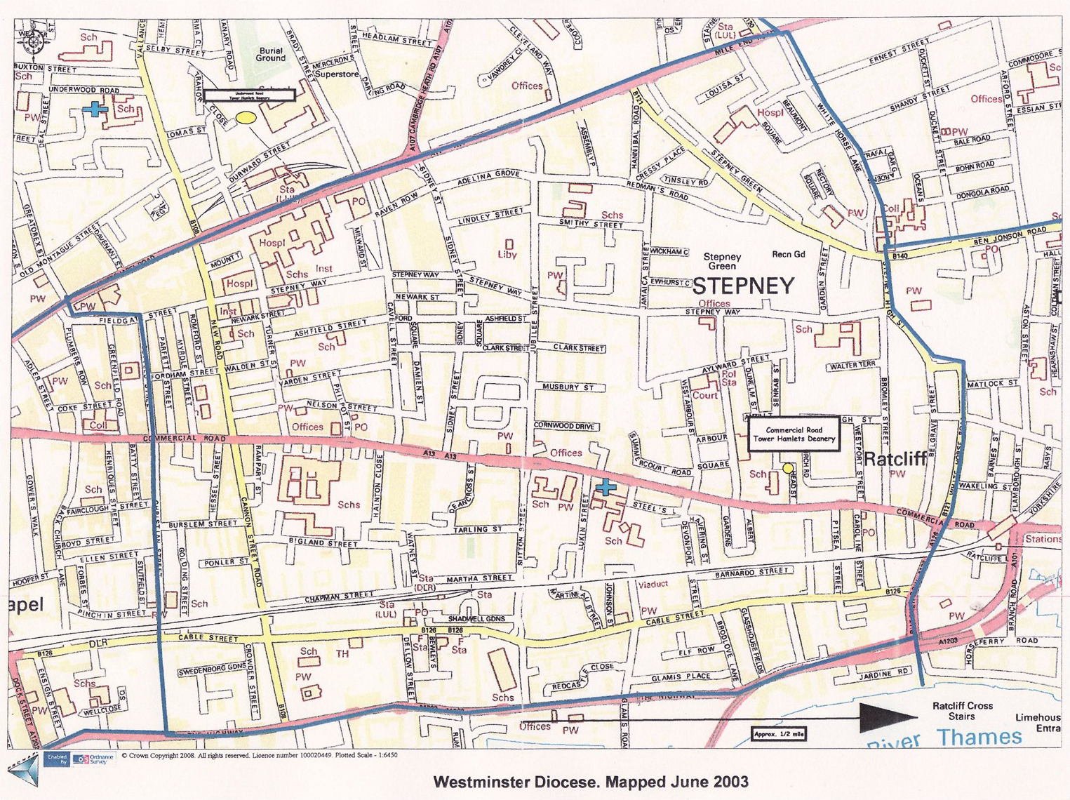
St Mary & St Michael Parish Boundary

- Other Catholic children.
- Other ‘looked after’ children and Catholic children who have been adopted or made subject to child arrangements orders or special guardianship orders, immediately following having been looked after.
- Children of Catechumens and members of an Eastern Christian Church.
- Christians of other denominations whose application is supported by a certificate of baptism or by a letter from a minister of religion confirming membership of the faith community.
- Children of other faiths whose application is supported by a letter from a religious leader confirming membership of the faith community.
- Any other applicants.
Where the offer of places to all the applicants in any of the categories listed above would lead to oversubscription these provisions will be applied in the following order:
- The Governing Body will give top priority after the appropriate category of ‘looked-after children’ to an application within any of the above criteria where evidence is provided at the time of application of a special pastoral, social or medical need. To demonstrate an exceptional pastoral, social or medical need of the child which can only be met at this school, the Governing Body will require written evidence from an appropriate professional, such as a social worker, doctor or priest.
- The attendance of a brother or sister at the school at the time of proposed admission will increase the priority of an application within each category.
- Children of staff members who have been employed for a minimum of two years at St Mary & St Michael will have third priority within each category.
Where the final place is offered to a child of a multiple birth i.e. twin, triplet etc, the remaining child/ren will also be offered a place, even though it will mean exceeding the published admission number.
Tie Breaker
In the event of oversubscription in the categories above, priority will be given to children who live closest to the school by the shortest walking distance. A digital ordnance survey map is used to measure the distance from the home address to the school’s designated official entrance. The distance is measured from the centre point of the address to the centre point of the main entrance of the school, measuring along the centre line of the shortest approved route. The system will take account of local footpaths and public walkways with regard to the safety of the route. It does not take account of the location of pedestrian crossings. In the case of equidistance from the school or where there is more than one application from the same family competing for a single lottery, which will take in the presence of an independent witness.
Admission Appeals for unsuccessful applicants to the Reception Class and Years 1 to 6

Unsuccessful applicants have the right to appeal to an independent panel. Parents wishing to appeal should obtain a form from the school. This should be completed and returned to the school, marked for the attention of Clerk to the Admission Appeal Panel. In the case of applications for Reception 2026/2027 the deadline for appeals is on 15th May 2026.

Pupils with an Education, Health and Care Plan (EHC)
The admission of pupils with an Education, Health and Care Plan (EHC) is dealt with by a completely separate procedure. Details of this separate procedure are set out in the Special Educational Needs Code of Practice. If your child has an EHC Plan you must contact your Local Authority SEN officer. Children with an EHC Plan naming this school will be admitted.
Fair Access Protocols
The school is committed to taking its fair share of children who are vulnerable and/or hard to place, as set out in locally agreed protocols. Accordingly, outside the normal admissions round the governing body is empowered to give absolute priority to a child where admission is requested under any local protocol that has been agreed by both the Diocese and the governing body for the current school year. The governing body has this power even when admitting the child would mean exceeding the published admission number.
Reception Year Deferred Entry
Applicants may defer entry to school up until statutory school age i.e. the first day of term following the child’s fifth birthday. Application is made in the usual way and then the deferment is requested. The place will then be held until the first day of the spring or summer term. Applicants may also request that their child attend part-time until statutory school age is reached. Entry may not be deferred beyond statutory school age or beyond the year of application. Parents wishing to defer entry for summer born children should note that entry can only be deferred up until 1st April 2027.
In-Year Admissions

Applications for In-Year admissions are made in the same way as those made during the normal admissions round. Where there is no waiting list the child will be admitted. If more applications are received than there are places available then applications will be ranked by the governing body in accordance with the oversubscription criteria, with the following modifications: Catholic children without an offer of a school place elsewhere are given priority immediately after Catholic ‘looked-after’ children; similarly, other children without an offer of a school place are given priority immediately after other ‘looked-after’ children. If a place cannot be offered at this time then you may ask us for the reasons and you will be informed of your right of appeal. You will be offered the opportunity of being placed on a waiting list. This waiting list will be maintained by the Governing Body in the order of the oversubscription criteria and not in the order in which the applications are received. Names are removed from the list at the end of each academic year. When a place becomes available the Governing Body will re-rank the list so that an offer can be made.
Children educated outside their chronological age group

Any application for a child to be educated out of his/her age group will be considered by governors on an individual basis and will only be granted in exceptional circumstances. Parents should write to the Chair of Governors during the Autumn Term in the (academic) year of application, giving reasons and providing compelling professional evidence.

Waiting Lists
In addition to their right of appeal, unsuccessful candidates will be offered the opportunity to be placed on a waiting list. The waiting list will be maintained in order of the oversubscription criteria set out above and not in the order in which applications are received or added to the list. The waiting list will be held open for a full academic year.
Application Procedures and Timetable
Please check the Tower Hamlets website under school admissions for closing dates for applica- tions and offer dates timetable.
You will be advised of the outcome of your application initially by letter from the Local Authority on our behalf. If you are unsuccessful you may ask us for the reasons, related to the oversub- scription criteria listed above, and you have the right of appeal to an independent appeal panel.
If you do not complete both the forms described above and return them by the closing date, the Governing Body may be unable to consider your application fully and it is very unlikely that your child will get a place at the school.
Change of Details

If any of the details on either of your forms changes between the date of application and the receipt of the letter of offer or refusal, you must inform the school and the local authority immediately. If misleading information is given or allowed to remain on either of your forms, the Governing Body reserves the right to withdraw the place, even if the child has already started at the school.

NOTES: these notes form part of the oversubscription criteria.
- ‘Parent’ is the person or persons who have parental responsibility for the child.
- ‘looked after’ child’ has the same meaning as in Section 22 of the Children Act 1989 and means any child in the care of a local authority or provided with accommodation by them
(e.g. children with foster parents).

- ‘Catholic’ means a member of a Church in full communion with the See of Rome. This includes the Eastern Catholic Churches. This will normally be evidenced by a certificate of baptism in a Catholic Church or a certificate of reception into the full communion of the Catholic Church. For the purposes of this policy, it includes a looked after child who is part of a Catholic family where a letter from a priest demonstrates that the child would have been baptised or received if it were not for their status as a looked after child (e.g. a looked after child in the process of adoption by a Catholic family).
For a child to be treated as Catholic, evidence of baptism or reception into the Church will be required. Those who have difficulty obtaining written evidence of baptism should contact their Parish Priest who, after consulting with the Diocese, will decide how the question of baptism is to be resolved and how written evidence is to be produced in accordance with the laws of the Church.

- “’Certificate of Catholic Practice’ means a certificate issued by the family’s parish priest (or the priest in charge of the church where the family attends Mass) in the form laid down by the Bishops’ Conference of England and Wales. It will be issued if the priest is satisfied that at least one Catholic parent or carer (along with the child, if he or she is over seven years old) have (except when it was impossible to do so) attended Mass on Sundays and holy days of obligation for at least five years (or, in the case of a child, since the age of seven, if shorter). It will also be issued when the practice has been continuous since being received into the Church if that occurred less than five years ago. It is expected that most Certificates will be issued on the basis of attendance. A Certificate may also be issued by the priest when attendance is interrupted by exceptional circumstances which excuse from the obligation to attend on that occasion or occasions. Further details of these circumstances can be found in the guidance issued to priests http://rcdow.org.uk/education/governors/admissions/
- ‘Eastern Christian Church’ includes Orthodox Churches and is normally evidenced by a certificate of baptism or reception from the authorities of that Church.
- “Children of other Christian denominations” means children who belong to other churches and ecclesial communities which, acknowledge God’s revelation in Christ, confess the Lord Jesus Christ as God and Saviour according to the Scriptures, and, in obedience to God’s will and in the power of the Holy Spirit commit themselves: to seek a deepening of their communion with Christ and with one another in the Church, which is his body; and to fulfil their mission to proclaim the Gospel by common witness and service in the world to the glory of the one God, Father, Son and Holy Spirit. An ecclesial community which on principle has no credal statements in its tradition, is included if it manifests faith in Christ as witnessed to in the Scriptures and is committed to working in the spirit of the above.
- All members of Churches Together in England and CYTÛN are deemed to be included in the above definition, as are all other churches and ecclesial communities that are in membership of any local Churches Together Group (by whatever title) on the above basis.
- “Children of other faiths” means children who are members of a religious community that does not fall within the definition of ‘other Christian denominations’ at 7 above and which falls within the definition of a religion for the purposes of charity law. The Charities Act 2011 defines religion to include:
  - A religion which involves belief in more than one God, and
  - A religion which does not involve belief in a God.
Case law has identified certain characteristics which describe the meaning of religion for the purposes of charity law, which are characterised by a belief in a supreme being and an expression of belief in that supreme being through worship.
- “brother” and “sister” includes half-brother/sister, stepbrother/sister or adopted brother/sister.
- To demonstrate an exceptional social, medical or pastoral need of the child which can be most appropriately met at this school, the governing body will require written evidence from an appropriate professional, such as a social worker, doctor or priest.
- For the purpose of this policy, parish boundaries of St Mary & St Michael are shown on the attached map. Distances will be measured from the main entrance of the school in a straight line on a large scale map by the shortest walking distance using lit and made up public roads and paths.
- ‘Residential address’ is defined as the place where the child is resident for 50% or more of the school week.
- ‘Adopted’. Adopted means any child who has ceased to be looked after because they have been adopted and whose parents can give proof of this status.
- ‘Child Arrangements Order’ A Child Arrangements Order is an order under the terms of the Children Act 1989 s.8 settling the arrangements to be made as to the person with whom the child is to live. Children ‘looked after’ immediately before the order is made qualify in this category.
- ‘Special Guardianship Order’. A special guardianship order is an order under the terms of the Children Act 1989 s.14A which defines it as an order appointing one or more individuals to be a child’s special guardian.
The information obtained on the Supplementary Information Form and from the Local Authority will be used for the purpose of school admissions only and in compliance with the Data Protection Act 2018. For further information on the school’s privacy policy please visit the school website on www.st-marymichael.towerhamlets.sch.uk

